Activity sheet
What’s it like to be a refugee?
1. Working individually, read Face the Facts – Questions and Answers about Refugees and Asylum Seekers to gather the facts about refugees and asylum seekers. After you have finished reading, answer the questions below.
a) What is a refugee?
....................................................................................................................................................
....................................................................................................................................................
b) What is an asylum seeker?
....................................................................................................................................................
....................................................................................................................................................
Discuss your answers with your classmates.
2. Create the story of an imaginary family of asylum seekers (compare the information you have gathered above) using the questions in the text box below.
a) Why are they fleeing?
....................................................................................................................................................
....................................................................................................................................................
b) How many family members are there?
...................................................................................................................................................
c) What is their country of origin?
...................................................................................................................................................
d) Other relevant information?
....................................................................................................................................................
....................................................................................................................................................
You may wish to explore real-life personal stories of asylum seekers to help you to create your imaginary family. Useful information is available at:
Road to Refuge
Developed by the BBC, this site explores the stories of refugees from around the world, using first-person testimonies and in-depth interviews. http://news.bbc.co.uk/hi/english/static/in_depth/world/2001/road_to_refuge/
Scattered People
Developed through a partnership between Lifeline Brisbane, the Refugee Claimants Support Centre, and Brisbane City Council, this site includes the stories of refugee claimants and their response to seeking asylum in Australia. http://brisbane-stories.powerup.com.au/scatteredpeople/
Use Face the Facts – Questions and Answers about Asylum Seekers and Refugees, as a starting point for your research and explore the real-life stories of asylum seekers to gather ideas for your story.
3a. Imagine that you (and your group) are one of the family members seeking asylum in another country (parents, children, grandparents etc). What would you take with you?

Seeking refuge – what will you take with you?
You have half an hour before you must leave your home.
Work out the list of things that you would like to take with you. Think carefully about the items you include on your list:
- what will you need to survive the journey?
- what will you need when you arrive?
- what personal items will you take with you?
....................................................................................................................................................
....................................................................................................................................................
....................................................................................................................................................
....................................................................................................................................................
....................................................................................................................................................
....................................................................................................................................................
....................................................................................................................................................
You are allowed to take one small suitcase with you. You cannot take anything that doesn’t fit. You cannot take anything that has to be carried separately. You cannot ask family members to carry anything for you. Revise the list of things so that they will fit in your suitcase. Everyone in your group must agree about what’s on the list.
After you have finalised your list, identify ONE item you would keep if you had to leave all else behind.
....................................................................................................................................................
Explain why this item is important.
....................................................................................................................................................
....................................................................................................................................................
....................................................................................................................................................
....................................................................................................................................................

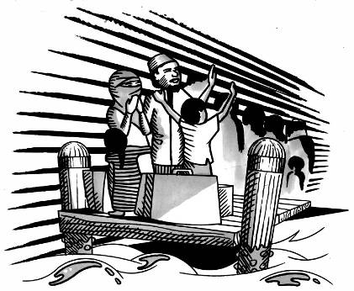

3b. After your group has finalised your list, report back to the class on the situation which forced you to become a refugee and explain the items you have included in your suitcase and why.
4. Using the lists your group has created and the scenario you imagined at the beginning of the activity, work individually to create a more detailed story about your refugee family.
You could present it as a:
- written testimony
- an imaginary diary of your refugee’s journey to Australia
- artwork
- an audio recording of your refugee’s story.

